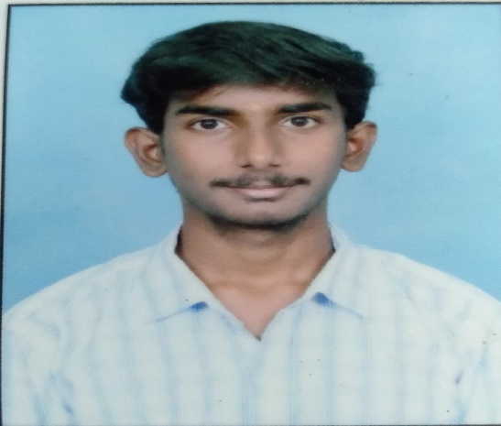

HEY I’M, VEMAVARAPU SAI

I’M UNDERGRADUATE STUDENT AT

VISAKHA INSTITUTE OF

ENGNEERING AND TECHNOLOGY

VISAKHAPATNAM

FRONTEND DEVELOPER PYTHON

PROGRAMMER PENTESTER

@VEMAVARAPU SAI